Postcards from the Future – Parental/Guardian competition consent form
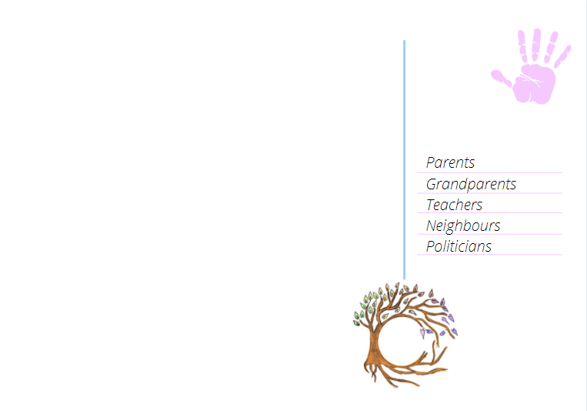
Dear Parent/Guardian,
On date your child will be participating in a creative workshop called ‘postcards from the future’ as part of a global imaginative activity to help address growing climate anxiety among young people and to celebrate the power of imagination and creativity.
The postcards produced could, with your permission, be submitted to an anthology competition where the winning children’s postcards will be featured in a creative climate anthology alongside interviews with climate leaders, academics and creative writers from around the world.
You can find out more about the anthology opportunity at https://www.createthefuture.earth/postcard-from-the-future
If your child’s postcard is chosen as a winner in the competition, the school will be contacted and will be given free access to view the completed anthology for all staff and parents.
Only the child’s name, age and country of residence will be published in the anthology. However, to submit this information, we must ensure parent/guardian has been given.
Please tick one of the following options:
I/We CONSENT for my child(ren)’s name, age and country of residence to be submitted with their postcard to the Create The Future schools postcard competition and for these details to be published online or in the final anthology in the event that my child(ren) are chosen as a competition winner.
I/We DO NOT CONSENT for my child(ren)’s name, age and country of residence to be submitted with their postcard to the Create The Future schools postcard competition.

Pupil’s name (please print) ____________________________________________________
Name of parent/guardian (please print) _____________________________________

Signature of parent/guardian _____________________________ Date _____________

