Postcards from the Future – Parental/Guardian consent form
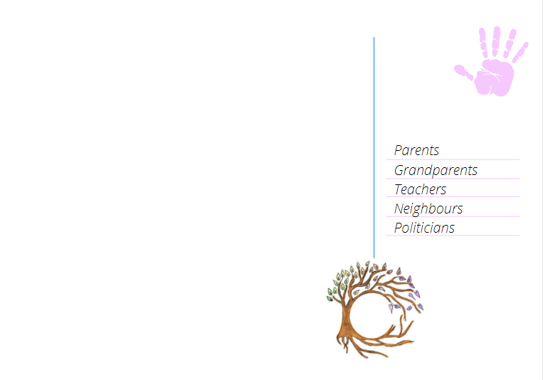
Dear Parent/Guardian,
On date your child will be participating in a creative workshop called ‘postcards from the future’ as part of a global imaginative activity to help address growing climate anxiety among young people and to celebrate the power of imagination and creativity in creating a better world for future generations.
The postcards produced could, with your permission, be submitted to a digital exhibition, where postcards from around the world will be featured on an interactive map and in an online gallery to tell the story of the next generation’s hopes for the future.
Some postcards may also be chosen to be published and featured in a creative climate anthology alongside interviews with climate leaders, academics and creative writers from around the world. If your child’s postcard is chosen for this opportunity, the school will be contacted and you will be given access to view the full anthology free of charge.
You can find out more about the project at https://www.createthefuture.earth/postcard-from-the-future
Only the child’s name, age and town/city will be published in the postcard gallery. However, to receive, store and publish this information, we must ensure parent/guardian has been given.
Please tick one of the following options:
I/We CONSENT for my child(ren)’s name, age and town/city to be submitted with their postcard to the Create The Future postcard gallery and for these details to be published online, and I understand that I have the right to ask that my child’s postcard be removed from the website at any time by contacting schools@createthefuture.earth
I/We DO NOT CONSENT for my child(ren)’s name, age and town/city to be submitted with their postcard to the Create The Future schools postcard gallery.

Pupil’s name (please print) ____________________________________________________
Name of parent/guardian (please print) _____________________________________

Signature of parent/guardian _____________________________ Date _____________

